Room 4 Question 1
Low Rectal Cancer
Stem: 80 y male presenting with pain with defecation, blood on the toilet paper when he wipes, and weight loss over the last three months. He is physically active and walks 2 miles a day with his dog without chest pain or sob.
Past medical history : CAD with prior 3v CABG 10 years ago, HTN.
Prior surgeries include CABG, lap chole and open right inguinal hernia repair.
Physical exam is normal except for external hemorrhoids without stigmata of bleeding and a firm mass 4cm in size about 3cm from the anal verge, extending 50% around the circumference. Mobile on palpation. How would you proceed?
Labs: CMP no abnormalities, CBC with Hgb 10.2

Any other information you would like to know? Any Additional Workup or Studies:
- Tumor markers? CEA 15
- Last colonoscopy? More than 10 years ago, he was told he has hemorrhoids.
Proceed with full colonoscopy?! --- Who will do it?-- I will do it - describe it
On colonoscopy you find, no evidence of synchronous lesions, you biopsy the mass and it reveals adenocarcinoma (Resident should state they will do the colonoscopy themselves, able to describe it, resident should obtain and wait for biopsy results recognizing that histopathology of the tumor will dictate management)
What would you like to do now? Staging Work up
1. CT scan chest/abdomen/pelvis: No metastases
2. MRI pelvis (superior to endorectal US): Shows invasion of the tumor into the muscularis propria (T2 lesion) with two mildly enlarged lymph nodes in the perirectal tissues.

How would you manage this patient?
- Multidisciplinary tumor board discussion.
- Total Neoadjuvant Therapy . Do all rectal cancer patients get neoadjuvant treatment? T3 and higher / Any T with N+ve on clinical workup)

Patients conclude their neoadjuvant treatment without complete response to treatment on workup and sphincter still involved , you are counseling the patient for resection
patient tells you with chemoradiotherapy he suffered incontinence, and he doesn’t want that to continue for the rest of his life, what would you offer

APR with a total mesorectal excision with negative colon radial margin (CRM)

Describe it : After bowel prep with mechanical , antibiotic prophylaxis, mark & pre-op for ostomy site

a. Abdominal portion: (Open / lap / Or Robotic … Lateral to medial or medial to lateral dissection)
i. Start with patient in dorsal lithotomy, lower midline celiotomy, examine for mets, mobilize the sigmoid colon along white line of Toldt or via medial to lateral approach score the peritoneum along the right side, identify the inferior mesenteric artery , , identify left ureter, and perform high ligation.
ii. Enter the mesorectal plane by scoring the peritoneum, use sharp dissection to circumferentially dissect sharply to obtain total mesorectal excision, carry down to the pelvic floor.

b. Perineal portion:
i. Elliptical incision 2-3 cm from anal verge
ii. Place lone star retractor ii. Incision to ischiorectal fossa
iii. Carry dissection posteriorly, palpate the coccyx, stay anterior to this and divide the anococcygeal ligament.
iv. Enter the peritoneal cavity.
v. Resect the levator ani muscle laterally.
vi. Continue the dissection anteriorly along the rectum between the prostate and the rectum.
vii. Close the perineal wound in multiple layers, leave drain.

Scenario: What if the mass is palpated at 4cm from the anal verge and is
- 2cm in size
- Only 20% of the circumference affected.
- Mobile on exam
- Biopsy demonstrates adenocarcinoma, well differentiated with no lymphovascular or perineural invasion.
- Colonoscopy shows no other lesions
- MRI consistent with (T1 tumor) without suspicious lymphadenopathy
- CT C/A/P with no metastatic disease.
How would you manage?
Wide Local excision. - What’s your margin? 1 cm - How deep you go? Full thickness to the perirectal fat.

Scenario 2: In a different patient, what if the tumor is in the upper rectum, biopsy proven adenocarcinoma. MRI pelvis demonstrates T1 lesion at 15cm from the anal verge, no suspicious lymphadenopathy, above and without involvement of the peritoneal reflection. Your patient has excellent continence and bowel control at baseline. What surgery would you offer?

Low anterior resection, with tumor specific mesorectal excision.

Room 4 Question 2
Ischemic Lower Extremity. (Reviewed by Dr. Yamaguchi)
Stem: You are called to the PACU to evaluate one of your partner’s post op patients, who is a 65-Year-old-male who is about 2 hours post op from an Aorto-Bifem bypass which was performed for intermittent claudication secondary to aortoiliac occlusive disease.
When he first arrived in the PACU, he had palpable DP and PT pulses bilaterally with pink and warm feet. Now he is complaining of left leg discomfort, and states that his left leg feels cooler than his right. His right DP/PT pulses are palpable, but his left DP/PT pulses are not, and no left leg doppler signals are present, except for a faint venous doppler at the popliteal. Your partner is across town performing emergency surgery and is unavailable.
Vitals: 37 C°, HR 70, BP 130/80, RR 12, O2 100% RA.

What is your differential diagnosis?
- Ischemic limb secondary to...
1. Early graft thrombosis
2. Obstructed anastomosis (dissection flap, or technically incorrect anastomosis)
3. Kinked/twisted graft limb
4. Atheroembolization
5. Proximal aortic dissection
6. Cardiac embolus
What Additional Workup or Studies you need?!
1. Review the op note from the Aorto-Bifem if possible.
2. EKG: Normal in this case.

What would you like to do now?
1. Ensure the patient is anticoagulated with heparin
2. Bedside duplex if it can be performed immediately without delay of treatment
3. Return to OR to re-assess graft and perform thrombectomy.
1. Return to OR.
2. Open the left groin.
3. Re-evaluate anastomosis, does it need revision or patch angioplasty to ensure outflow?
Re-open the common femoral anastomosis.
4.Perform thrombectomy with Fogarty balloon.
5. Ensure good bleeding from both proximal and distal to the anastomosis.
6. Check pulses/doppler signals intra-op and before leaving the OR

Scenario 2: Same patient, a moderate sized thrombus is recovered from the anastomosis during takeback with thrombectomy. What steps could have been performed in the initial operation to minimize the risk of this complication?
1. Ensure the patient is fully anticoagulated prior to arterial clamping, ACT >250 with heparin.
2. Gentle handling of the arterial structures
3. Needle passage from inside to outside on the artery wall to prevent dissection flap
4. Bleed the conduit and the distal arteriotomy to flush out any thrombus
developed intraop
5. Ensure both proximal and distal flushing with heparin prior to re-anastomosis

Scenario 3: Same patient, but he has palpable bilateral DP/PT pulses, and is complaining of blue discoloration, coolness and discomfort in his bilateral feet below the ankle. On physical exam he has a petechial rash on his forefoot, and a cyanotic blue first toe.

1. Diagnosis: Blue toe syndrome, secondary to atheroembolization
2. Perform ABI and Toe-Brachial index at bedside.
3. Consider imaging the chest/abd/pelvis with CTA to evaluate for embolizing
lesions or aneurysmal disease.
4. Give aspirin, statins
4. No extra anticoagulation, may destabilize further embolus.

Room 4 Question 3
Spontaneous Pneumothorax (Reviewed by Dr. Speicher)
Stem: A 65-year-old man with presents with acute onset shortness of breath. He regularly has dyspnea on exertion but suddenly became short of breath at rest 1 hour ago. He has new right-sided chest pain, which he describes as knife-like and worse on inspiration. He denies recent chest trauma.
PMH: Chronic obstructive pulmonary disease (COPD), hypertension, and a 50 pack-year history of smoking
On physical examination, he is tachycardic, hypertensive, tachypneic, and his oxygen saturation is 85% on room air. He has decreased breath sounds on the right side, decreased chest expansion on the right, and hyperresonance to percussion on the right. His trachea is midline.

What should you do immediately and what is your work up?
- Place on Supplemental oxygen : O2 Sat improved
- EKG: Sinus Tachycardia , no ischemia
- Cardiac Enzymes.
- Chest X-ray
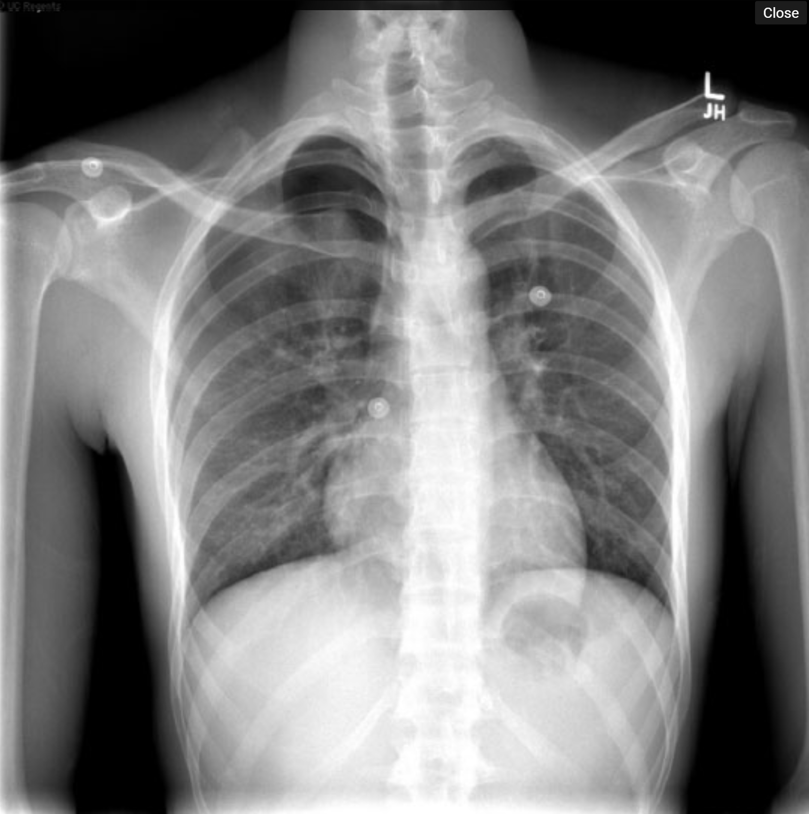
- Bedside Chest US
- CT chest : Right side pneumothorax : highly useful for older patients with chronic lung disease in order to describe the severity and extent of the pathology for surgical planning.
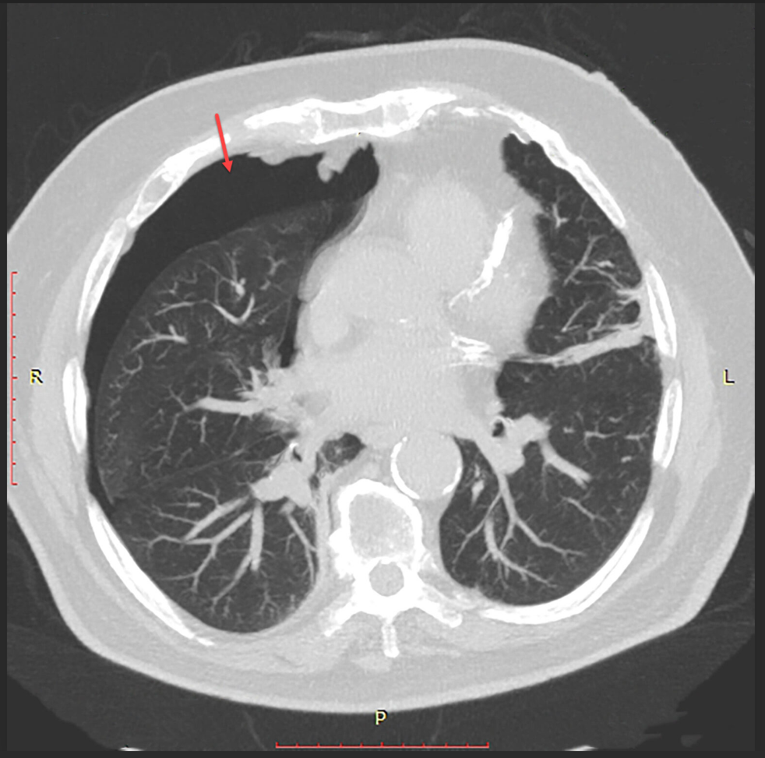

What is your differential diagnosis and management plan?
  - Pneumothorax (Primary / Secondary)
  - MI
  - PE
  - Aortic dissection
  - Pneumonia
  - Tension pneumothorax

Scenario: You placed a chest tube, air leak persisted more than 3 days, what would you do?
- Repeat imaging.
- Consider surgical intervention:
  - Video-assisted mechanical or talc pleurodesis.
  - Blebectomy.
  - Pleural tent procedure.
  - Blood patch of 50 mL of the patient’s own blood.
- Preop evaluation? Patients with long term COPD need cardiac and ABG assessment to make sure they can tolerate one lung ventilation for surgery.
Describe VATS (Video-Assisted Thoracoscopic) Bleb/Bullae Resection and Pleurodesis?
- Double-lumen endotracheal tube.
- Position the patient in the lateral decubitus position with single lung ventilation.
- Place the VATS camera port at the 7th intercostal space in the posterior axillary line.
- Depending on the location of the pathology, one or two additional ports may be placed in the 5th -9th intercostal spaces.
- Grasp the affected tissue and apply the endoscopic stapler across the base of the bullae/bleb. Use a linear GIA staple load.
- Abrade the parietal pleura through the VATS ports. This can be accomplished by using the electrocautery scratch pad, the electrocautery, or the argon beam coagulator.
- Consider mechanical vs. talc pleurodesis
- Remove the ports and insert a single chest tube into the inferior VATS port.

Scenario: After VATS and Bullae resection, patient has a persistent air leak after postoperative day 4, otherwise stable, now what?
- Water seal chest tube and if tolerates, may connect chest tube to a Heimlich valve, (outpatient suctionless device).
- If the patient can tolerate this device for 24 hours inpatient without reexpansion of the pneumothorax or clinical deterioration, then they may be discharged home with the suctionless device and strict return precautions for any worsening of symptoms.
Scenario: What if your patient was healthy 33 Y M , on presentation imaging showed small pneumothorax and patient O2 saturation improved while on oxygen, would you manage differently?
- Patient can be observed, if the pneumothorax is small.
- If the pneumothorax is radiographically stable over 6 hours and there is no progression of symptoms, they may be sent home with close follow-up.

